PREPARATION
- Familiarize yourself with this Study Guide.
- You can watch the sermon online HERE.
- Spend some time in prayer before your group gathers.
- You always have the option to use some or all the questions and/or prepare your own questions.

Welcome: Icebreaker – Name some people that brought you the message of Jesus?

Study Context: In the fall of 2020, our church did a series on The Gospel of the Kingdom. Our Life Group Ministry decided to supplement this series with a walkthrough of THE ENTIRE BIBLE (yes…from Genesis to Revelation) focusing on the Gospel of the Kingdom. You can find it at 3Crosses.org/fall2020. All this to say, the series ended with Pastor Danny Strange (Senior Pastor) and AJ Vanegas (Life Groups Director) having a podcast conversation on the Great Commission. For this week’s study guide help, feel free to click below!

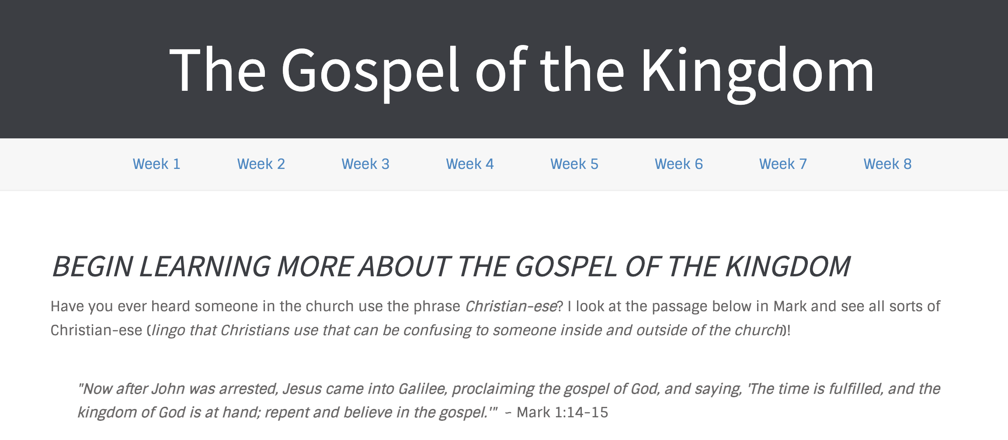
What’s Going on This Week

This week, Pastor Danny Strange brought us into the sixteenth week of our series titled A Church that Pleases God. Danny directed our attention to Matthew 28:16-20 as our church talks about how we are called to go back into the world on Jesus’ disciple-making vision that will reach the ends of the earth! Pastor Danny ironed out the apprentice-like definition of discipleship while suggesting that we look at the Great Commission as a command in the sense that Jesus outlines His vision and that we all find our places and roles within that grand vision. As you engage in this study guide, let’s wrestle with Danny’s challenges that will permeate the go section of the series as we think small, allow our own discipleship to Jesus be the source of discipling others, and follow God’s strategy that aligns with the life that God has called us to live.

“If the Great Commission gives you ‘Great Anxiety’, there is a chance you are reading it wrong. There is a chance you are reading it as a command to you personally, when it is a disciple-making vision for you to find your place in.” – Pastor Danny Strange

GROUP MEETING (60 – 90 minutes)
Worship (10 – 15 minutes)
Take time with your group and prepare your hearts as you enter the presence of God for this meeting.

Option 1: Worship Music  Have someone share their favorite song. You can find it online, play it, and even sing along with your group! Have them explain why the lyrics have impacted them! | Option 2: God Sightings  Spend time celebrating all of the small ways in which you’ve seen discipleship / apprenticeship to Jesus take place in your life or in the life of others around you. | Option 3: Imagination (Acts 1:6-8)  If the great commission is a vision of God to step into, allow the Lord to speak into your own creative imagination to paint a picture of how you might be used to make disciples.

Word #1: Explore Your Engagement with the Great Commission (15 – 25 minutes)

Primary Texts: Matthew 28:16-20 – This famous scripture outlines Jesus’ disciple-making vision given to his own 12 disciples that now echoes throughout all of God’s church across the world. In the original Greek, the verb that drives the opening sentence of Jesus’ command (vs. 19) is “make-disciples” making the verb “Go” a supporting word tethered closely to the disciple-making emphasis. In the scriptures, we see that discipleship is an identity that one inherits immediately upon faith in the gospel and baptism into the church (Acts 2 or Acts 14) a process one engages with over-time (Matthew 13:52, 27:57; Nicodemus in John 3, 7:50, and 19:39), and a word that equates closer to our English word apprentice (Matthew 9:35 – 10:4). As you read the famous Great Commission, what stands out to you knowing that make-disciples is the primary verb of the passage? What has been your experience with attempting to fulfill the great commission in your own life? Would you say that you have a relationship with Jesus that feels like an apprenticeship with Jesus? Why or why not?

Host Tip: Allow the differences in your group permeate the conversation on this familiar passage. When Susy or John share, A great follow up question to throw around the group is to ask, “do you all share the same experience as Susy or John?”

Word #2: Commit to an Apprentice-Making Culture (15 – 25 minutes)

Primary Texts: (1) Acts 17:26; Romans 12:1-8; (2) John 1:43-46, 4:27-30, 39-42; (3) Acts 9:15-22; Romans 11:13-14; 1 Corinthians 7:17-24 – As we think about how we can step into a deeper apprenticeship with Jesus, the following scriptures challenge us to (1) do not be afraid to think small knowing that God has appointed times, seasons, and boundaries for us to live while we exist on this disciple-making mission, (2) let the discipleship of others grow out of our own apprenticeship with Jesus as we invite others to “come and see” what we are doing, and (3) ask God to show us a strategy that works for the life He’s called us to live knowing that God has a unique role for all of us. (1) In what small ways might you and your group be able to activate your apprenticeship to Jesus? (2) As part of your apprenticeship to Jesus, who might God be calling you to pray for / invite into what you are already doing? (3) How has God’s strategy aligned with the season of life that you are in personally? What might God’s disciple-making strategy be for your Life Group and what do you need to do to commit to this strategy?

Host Tip: Many of us focus on the impact of the Great Commission on a personal level. This would be a great way to take the conversation! I also feel that a rather compelling angle to this question would be to think of the Life Group as one organism called to the exact same questions. Think through these questions corporately!

Witness (20 – 25 minutes)
- Pray that the Holy Spirit would show us how to become apprentices of Jesus.
- Pray that the Holy Spirit would show us some real people and real methods of discipleship this week.
- Pray for any individual prayer request that comes up in your group.
- Pray for the entire group and how they may be able to participate in future group meetings.
- Pray for an interaction with someone who you can invite into your next group meeting!
- Pray for God’s hand in the multiplication and revival of your group!

Stay up to date with our Prayer Ministry by signing up to be an intercessor online at 3Crosses.org/pray!

Throughout the Week

- Prepare for Next Week: Celebrate New Life - Primary Text: Matthew 5:13-15 — Before we talk about active things we can go and do for Jesus in this world, let’s start with a simple truth: You are representing Jesus by simply existing in the world in which he’s placed you.

- Follow up between group members: Have each member of the group pick one other group member to follow up with about how they are growing in their faith as they learn to keep in step with wherever the Holy Spirit is leading them.

- Join relief efforts locally and around the world: Looking to contribute to what is going on both locally and around the world? Visit our website and volunteer in our neighborhood resource center or help sponsor an indigenous missionary!

- Life Groups 2022: For more information about joining a group, hosting a group, or general inquiries, contact AJ at avanegas@3crosses.org or Carmela at carmela@3crosses.org

