PREPARATION
- Familiarize yourself with this Study Guide.
- You can watch the sermon online HERE.
- Spend some time in prayer before your group gathers.
- You always have the option to use some or all the questions and/or prepare your own questions.

Welcome: Icebreaker – What was the most entertaining celebration you have ever been a part of?

Study Context: Enjoy this creative rendition of the conversation between Nicodemus and Jesus from the hit streaming series The Chosen!

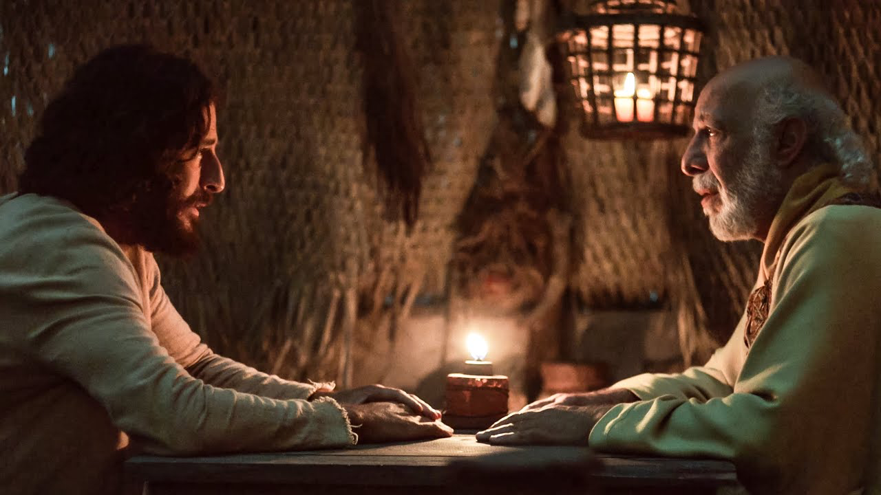
What’s Going on This Week

This week, Pastor Danny Strange brought us into the seventeenth week of our series titled A Church that Pleases God. Danny directed our attention to John 3:1-21 as we celebrated new life through the act of communion, child dedication, and baptism. By pointing us to Jesus’ conversation with Nicodemus, Pastor Danny explained how coming to the kingdom of God to experience a true spiritual birth when we come to Jesus. This spiritual birth is entirely an act of the Holy Spirit meaning it is out of our control and the Spirit blows wherever it would like. At the same time, the Spirit responds to our belief in the gospel of Jesus. As you engage in this study guide, let’s continue to celebrate new life as we continue to go throughout the East Bay Area making disciples of all nations, baptizing them in the name of the Father, the Son, and of the Holy Spirit!

“Spiritual life comes from the Spirit of God and Spiritual life begins when you believe in the gospel of Jesus Christ.” – Pastor Danny Strange

GROUP MEETING (60 – 90 minutes)
Worship (10 – 15 minutes)
Take time with your group and prepare your hearts as you enter the presence of God for this meeting.

Option 1: Worship Music  Have someone share their favorite song. You can find it online, play it, and even sing along with your group! Have them explain why the lyrics have impacted them! | Option 2: Celebrate New Life  Spend some time celebrating each other’s stories of spiritual re-birth in the group! Highlight the transformation that you saw in that moment you began to walk in the Spirit! | Option 3: Celebration (Phil. 4:4)  Did you know that celebration is a spiritual discipline? As we approach the end of this series, find ways to celebrate all of the ways the Lord has shown up in your group conversations!

Word #1: Share Your Born-Again Experience (15 – 25 minutes)

Primary Texts: John 3:1-21 – This famous scripture documents Jesus’ interaction with a member of the Jewish ruling council named Nicodemus. Nicodemus becomes a character whom the author John decides to follow throughout the Jesus narrative in order show a progressive spiritual rebirth that happens over the course of Nicodemus’ lifetime (see John 7:50-52; 19:39). What stands out to you about the conversation between Nicodemus and Jesus in this section of scripture? What were some of the changes you experienced when you were born again in the spiritual sense? How have passages like John 3:16 made an impact on your life?

Host Tip: These questions are designed to be extremely vague open for interpretation. Allow room for your group members to digest the scriptures here and continue to ask curious questions to keep the conversation going in the direction of celebrating the new spiritual life God has given us.

Word #2: Commit to a Life Governed by the Spirit (15 – 25 minutes)

Primary Texts: Romans 6:1-14, 8:1-11 – In these passages from Romans, Paul talks about what it means to undergo the ceremonial act of baptism inside of the church community as well as our call to sanctification as we continue to learn how to live governed by the Spirit of God. These are the ways in which we are called to engage in this new life. What are some of your thoughts regarding what Paul has to say on the topic of baptism? How is the Lord continually calling you to live by the Spirit in this new life born again by the Spirit of God? (3) How is God calling you to live according to the Spirit when it comes to engaging with your own group?

Host Tip: This might be a great reflection to pause and reflect on how the Lord is guiding this new life that he has given you. If there are no answers, perhaps this would be a good time as a group to spend some time engaging in a spiritual discipline like praying or silence so that you can hear from the Spirit of God.

Witness (20 – 25 minutes)
- Pray that the Holy Spirit would remind us of our new life in Jesus Christ.
- Pray that the Holy Spirit would show us what it means to live according to His leading.
- Pray for any individual prayer request that comes up in your group.
- Pray for the entire group and how they may be able to participate in future group meetings.
- Pray for an interaction with someone who you can invite into your next group meeting!
- Pray for God’s hand in the multiplication and revival of your group!

Stay up to date with our Prayer Ministry by signing up to be an intercessor online at 3Crosses.org/pray!

Throughout the Week

- Prepare for Next Week: A Transforming Identity - Primary Text: Matthew 5:13-15 — Before we talk about active things we can go and do for Jesus in this world, let’s start with a simple truth: You are representing Jesus by simply existing in the world in which he’s placed you.

- Follow up between group members: Have each member of the group pick one other group member to follow up with about how they are growing in their faith as they learn to keep in step with wherever the Holy Spirit is leading them.

- Join relief efforts locally and around the world: Looking to contribute to what is going on both locally and around the world? Visit our website and volunteer in our neighborhood resource center or help sponsor an indigenous missionary!

- Life Groups 2022: For more information about joining a group, hosting a group, or general inquiries, contact AJ at avanegas@3crosses.org or Carmela at carmela@3crosses.org

