PREPARATION
- Familiarize yourself with this Study Guide.
- You can watch the sermon online HERE.
- Spend some time in prayer before your group gathers.
- You always have the option to use some or all the questions and/or prepare your own questions.

Welcome: Icebreaker – In this season of your life, what does a typical day look like for you?

Study Context: This week’s text comes from one of the most famous public messages that Jesus ever gave: the Sermon on the mount. Enjoy this video from The Message of Christ which looks at the life and ministry of Jesus through the lens of its historical and Jewish significance.

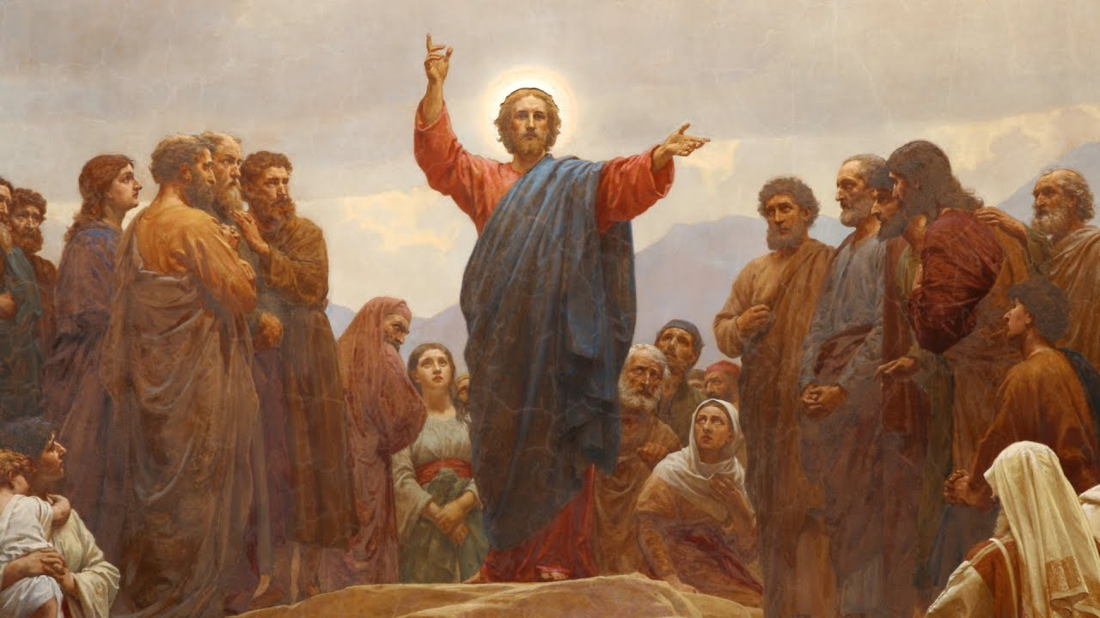
What’s Going on This Week

This week, Pastor Danny Strange brought us into the eighteenth week of our series titled A Church that Pleases God. Danny directed our attention to Matthew 5:13-16 as we discuss how we are called to go into our daily lives allowing the light of God’s presence in us to shine before others. By pointing us to Jesus’ teaching here from the Sermon on the Mount, Pastor Danny explains the extraordinary truth that we can make an impact for the kingdom in the world around us simply by existing as a Christian. Therefore, as you engage in this study guide and as you go throughout your daily lives across the East Bay Area, pray for all the ways you can continue to work with all of your heart unto God, model Christ and adopt the posture of a servant, express a heart of compassion for those who are struggling, act in a way that aligns with your Christian conscience, and be open for opportunities to share your story, impart wisdom, and pray for others!

“Open my eyes that I might see this act for what it is from the fixed vantage point of eternity, O Lord – How the changing of a diaper might sit upstream of the changing of a heart; How the changing of a heart might sit upstream of the changing of the world.” – Liturgy for the Changing of a Diaper
GROUP MEETING (60 – 90 minutes)
Worship (10 – 15 minutes)
Take time with your group and prepare your hearts as you enter the presence of God for this meeting.

Option 1: Worship Music  Have someone share their favorite song. You can find it online, play it, and even sing along with your group! Have them explain why the lyrics have impacted them! | Option 2: God Sightings (Mk. 2:17)  Whether it’s work, home, or anywhere else that seems “mundane,” spend time sharing how you have seen the Lord in your life knowing that your mere existence is a preserving force. | Option 3: Meditation  Sometimes, it is hard to identify the work of the Lord in ordinary life. Spend some time reflecting on all of the ways God has brought you to where you are. Be prepared to share what you learn.

Word #1: Identify the Opportunities to which God has Led You (15 – 25 minutes)

Primary Texts: Matthew 5:13-16; Romans 12:1-2 – The passage about the salt and light informs us that our very identity as Christians can act as a preserving agent for our community as well as a light so long as we allow God’s presence to shine through us. The Romans passage builds off the warning in Matthew because we are warned that the salt can lose its saltiness and the light can be extinguished if we begin to conform to the patterns of this world rather than remaining distinctly Christian. What stands out to you about this key teaching in the Sermon on the Mount? What are some of the opportunities in your life in which you feel like you are the salt and the light and how does this passage challenge you? What are some of the ways that you have seen God shine his light in your sphere of influence? What are some of the ways that you feel that you are losing your saltiness or covering up the light of God’s presence in you?

Host Tip: This is a chance to explore the different ways God has called us to go on mission across the East Bay Area. As a Host, recognize that there may be a sense of guilt or shame around not sharing the gospel in these spaces so allow room for your group to wrestle with what God is calling us to do knowing confidently that our very identity as Christians and vessels of the Holy Spirit bring preservation to our situation.

Word #2: Go Into Your Community Confident of Your Identity (15 – 25 minutes)

Primary Texts: Colossians 3:12-25; 1 Peter 3:13-17 / Supporting Texts: Proverbs 16:3; 1 Corinthians 10:31-33; Philippians 2:4-11; 4:4-9; Romans 8:12-17 – The following passages list off a variety of ways we can take our Christian identity into daily life living as real and genuine Christians wherever we are at. Below is the list of encouragements that were given to the church family (a) whatever you do, do it with all your heart, (b) work to please God and act with integrity, (c) model Christ and adopt the posture of a servant, (d) have a heart of compassion for those who are struggling, (e) refuse to act in a way that violates your conscience, (f) be open to opportunities to share your story, impart wisdom of pray for others. Which one of these passages or specific exhortations stands out to you the most and why? How might your group hold you accountable to these action steps and challenge you to abide in Jesus so that you can let your light shine amongst your sphere of influence?

Host Tip: Spend some time really pressing into the application section of this study guide considering we are talking about the go section of our series. If there are ways to team up as a group to hold each other accountable, allow the group time to develop this practice!
Witness (20 – 25 minutes)
- Pray that the Holy Spirit would remind us of our identity as salt and light in the community.
- Pray that the Holy Spirit would show us what it means to live as genuine Christians in our daily lives.
- Pray for any individual prayer request that comes up in your group.
- Pray for the entire group and how they may be able to participate in future group meetings.
- Pray for an interaction with someone who you can invite into your next group meeting!
- Pray for God’s hand in the multiplication and revival of your group!

Stay up to date with our Prayer Ministry by signing up to be an intercessor online at 3Crosses.org/pray!

Throughout the Week

- Prepare for Next Week: On Mission in the Workplace - Primary Text: TBD (Guest Speaker) — What does it look like to live out life with Jesus in the real world here in the East Bay Area?

- Follow up between group members: Have each member of the group pick one other group member to follow up with about how they are growing in their faith as they learn to keep in step with wherever the Holy Spirit is leading them.

- Join relief efforts locally and around the world: Looking to contribute to what is going on both locally and around the world? Visit our website and volunteer in our neighborhood resource center or help sponsor an indigenous missionary!

- Life Groups 2022: For more information about joining a group, hosting a group, or general inquiries, contact AJ at avanegas@3crosses.org or Carmela at carmela@3crosses.org

