PREPARATION
- Familiarize yourself with this Study Guide.
- You can watch the sermon online HERE.
- Spend some time in prayer before your group gathers.
- You always have the option to use some or all the questions and/or prepare your own questions.

Welcome: Icebreaker – Happy Father’s Day! Describe one of the most significant memories with your Father?

Study Context: Enjoy this brief video on work as worship! If you are interested in learning more about this specific Right Now Media series, let us know and we can get you connected with an account!

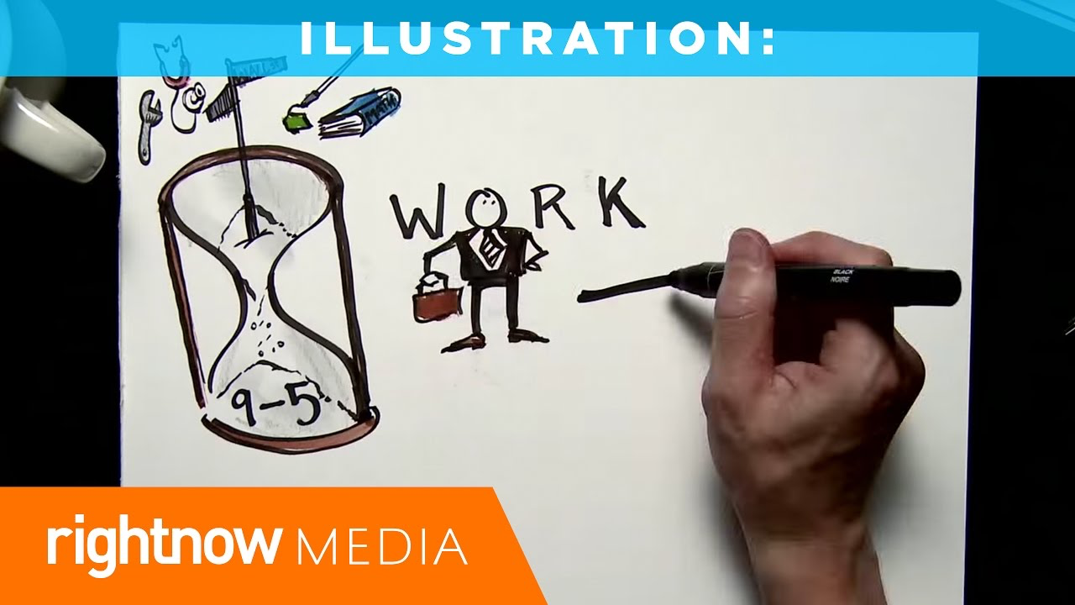
What’s Going on This Week

This week, Justin Redemer, Director of Men’s Ministry at 3Crosses, brought us into the nineteenth week of our series titled A Church that Pleases God. Justin directed our attention to Colossians 3:23-24 and other related passages as we discuss how we are called to go into our workplaces and work diligently as unto the Lord. By alluding to a variety of passages explaining the theology of work, Justin outlines how God plans to use his church body to become (1) space makers, (2) space takers, or (3) kingdom earners. As you engage in this study guide and as you go back into your workplaces across the East Bay Area, spend some time identifying what role God has called you to fulfill in your workplace and brainstorm all of the ways that you might be able to creatively integrate your faith into your workspace.

“God’s gift to us as believers is the knowledge that through Him, none of our work is wasted.” – Justin Redemer
GROUP MEETING (60 – 90 minutes)
Worship (10 – 15 minutes)
Take time with your group and prepare your hearts as you enter the presence of God for this meeting.

Worship Music  Have someone share their favorite song. You can find it online, play it, and even sing along with your group! Have them explain why the lyrics have impacted them! | God Sightings (Is. 55:10-11)  Today’s lesson focusses on God utilizing every opportunity. Spend time sharing how you have seen the Lord in your workspace knowing that God’s word will never return void. | Silence  Our busy lives can cloud our ability to discern the Lord’s work in our lives. As we prepare to talk about work, spend some time yielding to the Spirit’s voice silencing the business of life.

Word #1: Explore and Discuss your Work Environment (15 – 25 minutes)

Primary Texts: (WHO) Colossians 3:23-24; Philippians 2:14-15 / (HOW) Romans 12:11; Proverbs 14:23 / (WHY) 1 Timothy 5:8; 2 Thessalonians 3:10 – These are the list of passages that briefly explain the theology of work in the scriptures answering the questions who Christians work for, how Christians work, and why Christians work. What challenges you the most about these passages considering your workplace environment? What are some of the ways that you have seen (or are currently seeing) the Lord move in your workspace? How has working along these who, how, and why principles affected the way people see you in your job and which category do you feel like is lacking the most in your own work?

Host Tip: Oftentimes, we feel that our spiritual lives and our working lives do not overlap. There might be people in your group who have never shared about their own work in the group thinking that it is either not important or relevant even though for a lot of us, we spend most of our time working. Allow this to be a safe environment to share about work and be sure to ask a lot of curious questions so that you can determine where to validate where and where to encourage.

Word #2: Maximize your Vocational Opportunity (15 – 25 minutes)

Primary Texts: (Space Maker) Acts 10:7-8; (Space Taker) Acts 17:18-20; (Kingdom Earner) Acts 18:2-4 – The following passages show us how the early church strategically took advantage of different opportunities that were afforded to them. The Space Maker is like an executive who can set certain policies to allow room for faith to be expressed in the workplace. The Space Taker is a subordinate who steps into those spaces where the message of the gospel can be introduced. Finally, the Kingdom Earner is someone who works to fund a variety of kingdom ministries! Which one of these roles do you feel like the Lord has called you in this season of your life? Can you describe an example where you have seen these 3 roles in your own life or in the life of someone around you? In what ways can your Life Group help you to step into one of these roles in your current situation!

Host Tip: Spend some time really pressing into the application section of this study guide considering we are talking about the go section of our series. If there are ways to team up as a group to hold each other accountable, allow the group time to develop this practice!

Witness (20 – 25 minutes)
- Pray that the Holy Spirit would remind us of our Heavenly CEO!
- Pray that the Holy Spirit would reveal different opportunities to us in our workspaces.
- Pray for any individual prayer request that comes up in your group.
- Pray for the entire group and how they may be able to participate in future group meetings.
- Pray for an interaction with someone who you can invite into your next group meeting!
- Pray for God’s hand in the multiplication and revival of your group!

Stay up to date with our Prayer Ministry by signing up to be an intercessor online at 3Crosses.org/pray!

Throughout the Week

- Prepare for Next Week: On Mission in the Home - Primary Text: TBD (Guest Speaker) — How do we go into our own homes and bring the mission of Jesus with us?

- Follow up between group members: Have each member of the group pick one other group member to follow up with about how they are growing in their faith as they learn to keep in step with wherever the Holy Spirit is leading them.

- Join relief efforts locally and around the world: Looking to contribute to what is going on both locally and around the world? Visit our website and volunteer in our neighborhood resource center or help sponsor an indigenous missionary!

- Life Groups 2022: For more information about joining a group, hosting a group, or general inquiries, contact AJ at avanegas@3crosses.org or Carmela at carmela@3crosses.org

