PREPARATION
- Familiarize yourself with this Study Guide.
- You can watch the sermon online HERE.
- Spend some time in prayer before your group gathers.
- You always have the option to use some or all the questions and/or prepare your own questions.

Welcome: Icebreaker – Who is a person in. your life who has demonstrated a healthy use of authority?

Study Context: Throughout this series, be sure to check out the 3Crosses Podcast for Going Deeper episodes on 1 Peter! Click the image below to access the podcast content.

What’s Going on This Week

This week, Pastor Danny Strange led us into the ninth week of our series titled EXILES: Strangers in a Strange World. In our methodical walkthrough of Peter’s first epistle, Danny directed our attention to 1 Peter 2:13-25 to see how Peter calls on the community of Jesus-followers to navigate the tension between submitting to human creatures in positions of earthly authority and submission to God as the ultimate authority in our lives. In these passages, the societal structure of the ancient Greco-Roman world is addressed as Peter boldly attributes human value to the marginalized of the society (slaves, women, citizens). However, Peter’s call for submission leading to gospel transformation in society straddles the line of (a) adhering to an ethic that is good in the eyes of culture and (b) subverting the 1st century cultural climate by living according to the truth of God’s word as exemplified by the suffering posture of Jesus. As you engage with this study guide, ask the Lord to reveal where you might be able to submit to earthly creatures who hold authority in your life and ask the Spirit to give you the wisdom necessary to discern how to respond to your situation in a Christ-like manner.

“The Biblical witness is the ONLY piece of writing in the ancient world that speaks director to the oppressed party. Peter almost exclusively talks to slaves, wives, and subjects…There’s a subtext in this passage that speaks revolutionary truth to power. Government agents, you serve God. Husbands, live with your wives in an understanding way because they are co-heirs with you in the gracious gift of life. Masters, you are in an oppressive system where you are enslaving your own brothers and sisters.” – Pastor Danny Strange Sermon Notes
GROUP MEETING (60 – 90 minutes)
Worship (10 – 15 minutes)
Take time with your group and prepare your hearts as you enter the presence of God for this meeting.

Worship Music  Have someone share their favorite song. You can find it online, play it, and even sing along with your group! Have them explain why the lyrics have impacted them! | Meditation (Ephesians 5:15-21)  Today’s conversation revolves around submission to one another! Spend time meditating on what it looks like in your life to willingly place yourself beneath someone for their best | A Few Words on Slavery  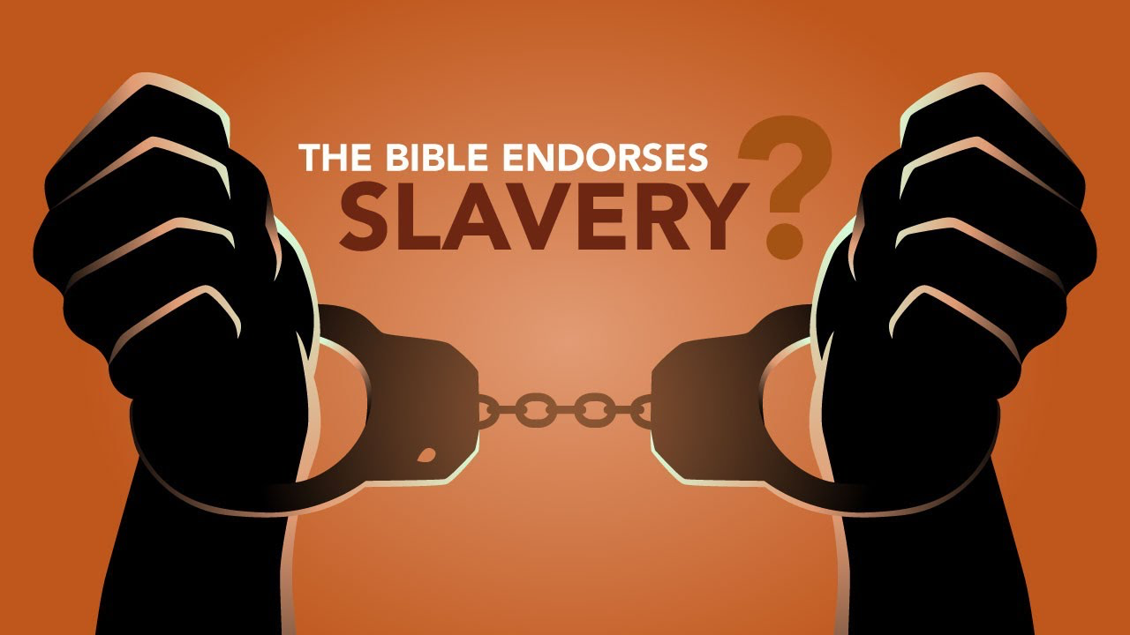

Word #1: Explore the Concept of Submission in Your Context (15 – 25 minutes)

Primary Text(s): 1 Peter 2:13-25

Supporting Texts: Romans 13 (Submission Towards Government); Exodus 1:15-17; Daniel 3, 6; Luke 23:8-9; Acts 5:27-32 (Subversion of Government) Matthew 21:12-13, 23:1-39 vs. Matthew 5:38-39 (Non-Retaliation vs. Rebukes) Romans 6:15-23; 1 Corinthians 7:21-23; Gal. 5:1-14 (Important Slavery Passages); Ephesians 5:15-6:9; Colossians 3:18-4:1 (Household Codes); Isaiah 52:13-53:12 (Old Testament Quotation)

In this week’s key text, Peter speaks about different components of the Greco-Romans societal structure and suggests that Christians occupying these roles (a) have human value and dignity in the eyes of God and (b) can act as a witness to Christ by the way they choose a posture of submission. What stands out to you in the text this week and the tense conversation about submission in general? What authority structures exist in your life right now and what does Christ-like submission look like in those cases? What are some of the challenges you face when you are trying to discern what is over-passive submission and what is over-aggressive retaliation?

Host Tip: The tension behind the submission concept is an easy one to keep in the realm of the theoretical. When people talk about submission, a helpful tool might be to ask to offer real-life and personal examples.

Word #2: Commit to a Posture of Submission (15 – 25 minutes)

Primary Texts: 1 Peter 2:20-25; Philippians 2:1-11; Galatians 5:16-26; Romans 8:26-30, 12:1-2; – One of the best ways to resolve the tension of when to adopt a submissive posture is to pray for discernment from the Holy Spirit dwelling inside of us and ask ourselves the question “what would Jesus do”? In what ways does Peter’s presentation of Jesus as the suffering servant in Isaiah 53 challenge you as you think about the power of submission? How might Jesus be calling you to have a heart posture that looks more like his and how might your life group come around you and hold you accountable?

Host Tip: Peter was a man of action!! In this series, I encourage you to spend a significant amount of time pressing into the application section of this study guide being personal as well as specific about application. Think of ways your group can hold each other accountable and seek to develop this practice over this series.
Witness (20 – 25 minutes)
- Pray that the Holy Spirit would guide us toward discernment when it comes to submission.
- Pray that the Holy Spirit would show us how we can become like Christ in all that we do.
- Pray for any individual prayer request that comes up in your group.
- Pray for the entire group and how they may be able to participate in future group meetings.
- Pray for an interaction with someone who you can invite into your next group meeting!
- Pray for God’s hand in the multiplication and revival of your group!
- Pray for the local ministry at 3Crosses and the global mission of God!

Stay up to date with our Prayer Ministry by signing up to be an intercessor online at 3Crosses.org/pray!

Throughout the Week

- Prepare for Next Week: The Secret to a Transformative Marriage: 1 Peter 3:1-7 — What does a “good” marriage look like? Not merely a marriage that’s fun or life-giving, but one that changes the world? Peter brings this concept of submission into the marriage relationship and shows us the power of serving the person God has brought into our lives and into our homes.

Suggested Reading Material:
The Message of 1 Peter by Edmund Clowney
Live No Lies by John Mark Comer

- Follow up between group members: Have each member of the group pick one other group member to follow up with about how they are growing in their faith as they learn to keep in step with wherever the Holy Spirit is leading them.

- Join relief efforts locally and around the world: Looking to contribute to what is going on both locally and around the world? Visit our website and volunteer in our neighborhood resource center or help sponsor an indigenous missionary!

- Life Groups 2022: For more information about joining a group, hosting a group, or general inquiries, contact AJ at avanegas@3crosses.org or Carmela at carmela@3crosses.org

