PREPARATION
- Familiarize yourself with this Study Guide.
- You can watch the sermon online HERE.
- Spend some time in prayer before your group gathers.
- You always have the option to use some or all the questions and/or prepare your own questions.

Welcome: Icebreaker – If you got the chance to meet one LEADER (besides Jesus), who would it be?

Study Context: Throughout this series, be sure to check out the 3Crosses Podcast for Going Deeper episodes on 1 Peter! Click the image below to access the podcast content.

What’s Going on This Week

This week, Pastor Danny Strange led us into the seventeenth and final week of our series titled EXILES: Strangers in a Strange World. In our methodical walkthrough of Peter’s first epistle, Danny directed our attention to 1 Peter 5:6-14 to see how Peter concludes his letter by calling on the church to humble themselves during their suffering, wake up to the spiritual warfare at hand, and stand firm against the Devil and his schemes. As you engage with the study guide this week, pay attention to (a) your attitude as you approach difficult situations in your life, (b) whether or not you are blaming the person for the situation as opposed to the spiritual entities animating the situation, and (c) if you are standing against the enemy confident that the Lord has conquered all things through the resurrection power of Jesus Christ!

“You are here on purpose. You are not lost or stranded, but here on mission
You are only here temporarily
You are here on mission.” – Danny Strange Sermon Notes – Final Takeaways

GROUP MEETING (60 – 90 minutes)
Worship (10 – 15 minutes)
Take time with your group and prepare your hearts as you enter the presence of God for this meeting.

Worship Music  Have someone share their favorite song. You can find it online, play it, and even sing along with your group! Have them explain why the lyrics have impacted them! | Meditation (Ephesians 6:10-20)  Today’s conversation revolves around the spiritual warfare behind situations of hardship. Spend some time meditating on this issue and ask the Lord to reveal the true war at hand. | A Look into Christian Suffering  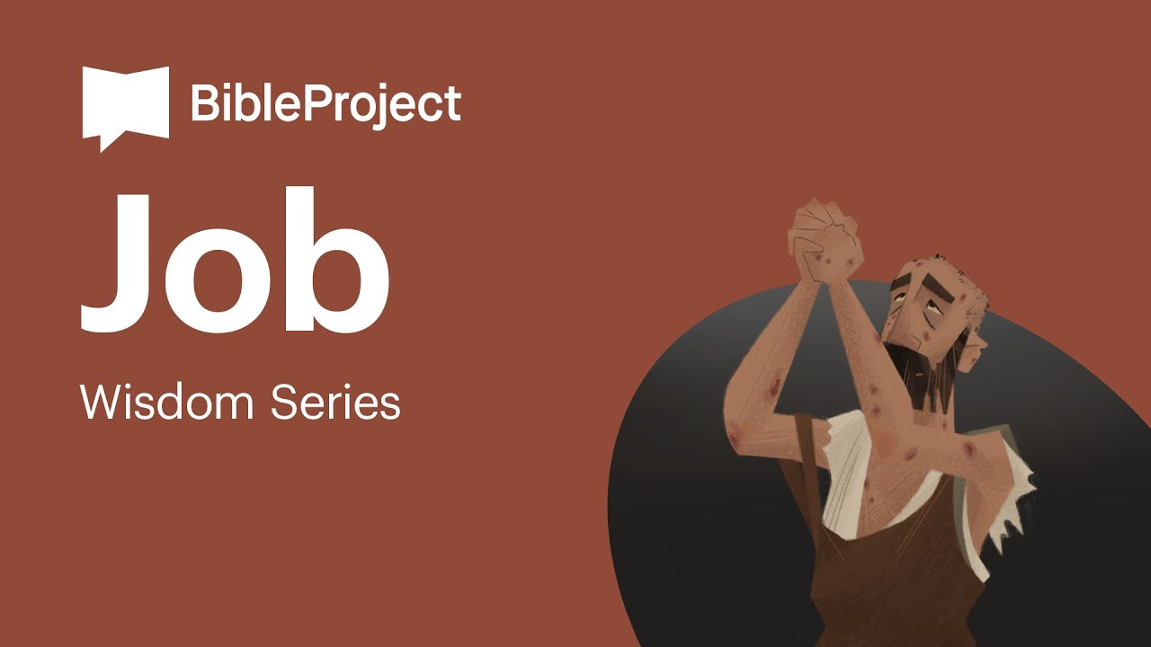

Word #1: Explore Your Attitude Toward Suffering (15 – 25 minutes)

Primary Text(s): 1 Peter 5:6-14

Supporting Texts: 1 Peter 1:7, 3:17, 4:12, 17-19 (Humble) Mark 4:19 (Cast Anxieties) Exodus 13:9; Deuteronomy 3:24, 4:34, 5:15, 7:19, 9:26, 11:2 (God’s Mighty Hand) 1 Peter 1:13 (Alert and Sober Minded);

In the closing section of his letter to the scattered church, Peter offers 3 commands – (1) to humble yourself and cast your anxieties on God knowing that what is happening is not somehow outside of God’s will for you, (2) to wake up from our slumber or our drunkenness in order to identify the spiritual war at hand, and (3) to stand firm in our faith against the Devil who is trying to claim his territory and scare us off. When you think about these 3 final commands in the context of suffering, what stands out to you? What are some ways that either humility, clear-mindedness, or standing firm could contribute to handling situations in your life?

Host Tip: This initial question is designed to scope out how people feel about the 3 commands given to us at the end of 1 Peter. Since the commands lean more heavily towards attitude rather than resolving the issue, pay close attention to your group discussion so that it would align toward the attitude of the believe as opposed to the efforts to resolve.

Word #2: Commit to a Posture of Humility Going to the Lord (15 – 25 minutes)

Primary Texts: Job 1 – 2:10; 28:1-28; 42:1-16 – At the conclusion of this series, we as a church have been called to apply what we have learned by approaching suffering knowing that God has us here on purpose, that we are only going to suffer “a little while”, and that we are on mission with our eyes fixed on the eternal glory to come. The book of Job offers us an amazing insight into someone undergoing this situation! What will you take away from this series as a stranger living in a strange world? What stood out to you the most about 1 Peter in general? Based on your study of 1 Peter, what do you feel the Lord is calling you to do?

Host Tip: Peter was a man of action!! In this series, I encourage you to spend a significant amount of time pressing into the application section of this study guide being personal as well as specific about application. Think of ways your group can hold each other accountable and seek to develop this practice over this series.

Witness (20 – 25 minutes)
- Pray that the Holy Spirit would give you a humble perspective to stand firm in suffering.
- Thank the Holy Spirit for the conclusion of 1 Peter and a great study!
- Pray for any individual prayer request that comes up in your group.
- Pray for the entire group and how they may be able to participate in future group meetings.
- Pray for an interaction with someone who you can invite into your next group meeting!
- Pray for God’s hand in the multiplication and revival of your group!
- Pray for the local ministry at 3Crosses and the global mission of God!

Stay up to date with our Prayer Ministry by signing up to be an intercessor online at 3Crosses.org/pray!

Throughout the Week

- Prepare for Next Week: Advent Hope – Isaiah 9:1-2 — Advent starts with a light at the end of the tunnel: “In the land of great darkness, a light has dawned.” We understand that for the people of Christ’s day, for us after a few years of difficulty, and for us as we long for the return of Jesus. This season reminds us that the light is coming.

- ADVENT 2022: Connect with us all season long over Christmas at Christmasat3Ccrosses.com

Suggested Reading Material:
The Message of 1 Peter by Edmund Clowney
Live No Lies by John Mark Comer

- Follow up between group members: Have each member of the group pick one other group member to follow up with about how they are growing in their faith as they learn to keep in step with wherever the Holy Spirit is leading them.

- Join relief efforts locally and around the world: Looking to contribute to what is going on both locally and around the world? Visit our website and volunteer in our neighborhood resource center or help sponsor an indigenous missionary!

- Life Groups 2022: For more information about joining a group, hosting a group, or general inquiries, contact AJ at avanegas@3crosses.org or Carmela at carmela@3crosses.org

